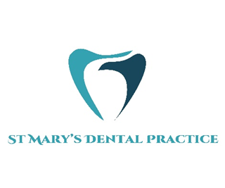

**Private Patient Registration Form**

Please provide the following information about your personal details.

All information given will be held in the strictest of confidence.

|  |  |
| --- | --- |
| Title (please circle) | Mr Mrs Miss Mst Ms Other_________________ |
| Forename(s) |  |
| Surname |  |
| Date of Birth | Male Female |
| Email Address |  |
| Full Postal Address | Post Code |
| Telephone | Home Mobile |
| Occupation |  |
| NHS Number (if known) |  |
| Do you require a downstairs surgery? (please circle) Yes No | |

|  |
| --- |
| Please tick if you would be happy to receive information about our services, products and any information relating to the practice we feel may be of interest to you.  POST ☐ TELEPHONE ☐ EMAIL ☐ TEXT ☐ |

|  |  |
| --- | --- |
| Next of Kin Details | |
| Title (please circle) | Mr Mrs Miss Mst Ms  Other…………………………………………………………. |
| First name |  |
| Surname |  |
| Contact Number |  |
| Relationship to you |  |
| Address | Post Code |

|  |  |
| --- | --- |
| When did you last visit a dentist? |  |
| Doctors Name and Address |  |
| Doctors telephone |  |

Please send completed forms to the following email: pvt.stmarysdentalpractice@protonmail.com

***Fees Information***

***Please note payment will be required at the time of booking a full list of our fees can be found on our website:*** [***https://stmarysdentalely.co.uk/fees***](https://stmarysdentalely.co.uk/fees)

***Safety Information***

***Our dental chairs have a safe working limit of 21 stone/135 Kgs. If you exceed this weight limit, unfortunately we will not be able to see you at the practice.***