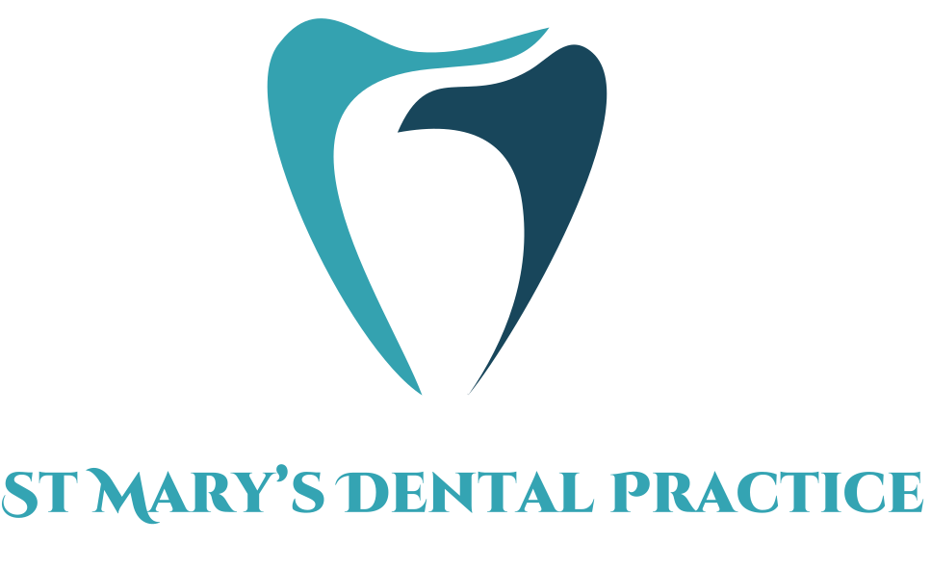

St Mary’s Dental Practice

Contact Number: 01353 662159
Email: Reception.stmarysdentalpractice@gmail.com

Address:
26 St Mary’s Street, Ely, CB7 4ES
CARE FOR YOUR DENTURES

Information for Patients

Special considerations

Metal Based Dentures
- Dentures containing metal such as Cobalt Chrome Dentures can be damaged by acidic cleansers such as.
- Safe to soak metal dentures in effervescent such as Steradent for 15 minutes.

Soft Linings

A soft denture lining can be done to improve the fit of your current dentures. Soft linings can prone to damage:

- Avoid hard bristled toothbrushes
- Avoid toothpaste and effervescent cleansers
- Avoid prolonged soaking in Milton solution

Reminders
- Use manufacturers instructors regarding use of denture cleaning solutions
- If you have any questions- always ask our staff
- Continue to attend regular dental check-ups/ appointments at recommended interval by your dentist

Why is it important to look after your dentures?
- Prevents bad breath
- Keeps dentures clean, can help them last longer
- Maintains healthy mouth and reduces risk of infections

Advice on getting used to a new set of dentures
- Increased saliva for a few days is normal
- Practice speaking aloud
- Start with soft foods and gradually introduce firmer foods
- Wear dentures during the day only unless advised otherwise by a dentist

How to look after your dentures?

Our recommendations for effective cleansing of acrylic (plastic) dentures:

- Rinse dentures after meals
- Brush with toothbrush and cold soapy water to remove debris
- Keep dentures safe in a denture box when not in use. When cleaning dentures, do so over a sink to avoid dropping and breaking dentures
- Soak dentures occasionally for 15- 20 minutes in a dilute Milton solution
- Soak overnight in water
- Do not wear at night (unless specified by the dentist)

