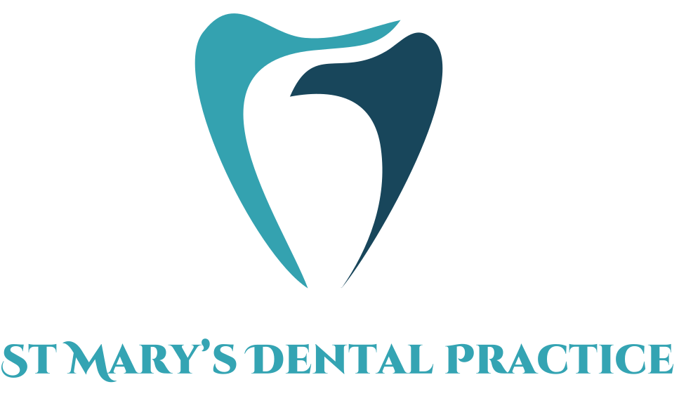

St Mary’s Dental Practice

Contact Number: 01353 662159
Email: Reception.stmarysdentalpractice@gmail.com

Address:
26 St Mary’s Street, Ely, CB7 4ES
Immediate Dentures

Information for Patients

The next day:
- Dentures can be removed (after 24 hours), unless specified differently by your dentist
- Start doing warm salty mouth rinses 2-3 times a day. Add teaspoon of salt to a cup of boiled water, and let is cool to a warm temperature to prevent burning yourself. Rinse for 1 minute gently, then spit out
- Start caring for you dentures per denture care advice leaflet

What to expect from your dentures

- Learning to get adjusted to a new set of dentures will take time and patience. Especially if these are your first set of dentures.
- Eating may feel a bit strange and difficult at first. We recommend you cut up your food into smaller pieces.
- Practice talking with the denture in by reading out aloud
- Pain and discomfort is expected so please insure revie appointments are booked for adjustments
- The dentures will eventually get looser. The dentures may need to be adjusted or a new set of dentures made. Please discuss and plan with your dentist.

Next appointment
- Please arrange and attend a follow up appointment soon after extractions for further adjustments
- If you have any concerns prior, contact the practice sooner
- If very sore and you can’t wear them, leave them out and take them to the dentist. The dentist may advice to wear them morning of the appointment to see where the denture rubs.

What are immediate dentures?
- Dentures that are made prior to extractions
- Denture is fitted on the day of extractions
- This can be done to replace any number of teeth
- Provides an immediate solution for aesthetic purposes

Advantage of immediate dentures
- You get a denture on the day of extractions, which maintains aesthetics whilst your bone and gum are healing

Disadvantages of immediate dentures
- Immediate dentures may not be the perfect fit as they are made by predictions on how the gum will look after extractions
- Immediate set of dentures can get loose and may not have the best fit 3-6 months post extractions. Meaning adjustments to current dentures may be needed or a new set of dentures made.
(please note immediate dentures and new set of long-term dentures are two separate costs)

First 24 Hours:
- Dentist may recommend leaving the dentures in for the first 24 hours after tooth extraction. This is not always the case so please check with your treating dentist
- If told to do so by the dentist, you can sleep with them in first night only. They should then be removed every following night to prevent infections
- If you are experiencing pain, you can take pain relief (as allowed by your medications and medical conditions and per packaging instructions). If not sure, please query with doctors or dentist
- Soft diet advised

