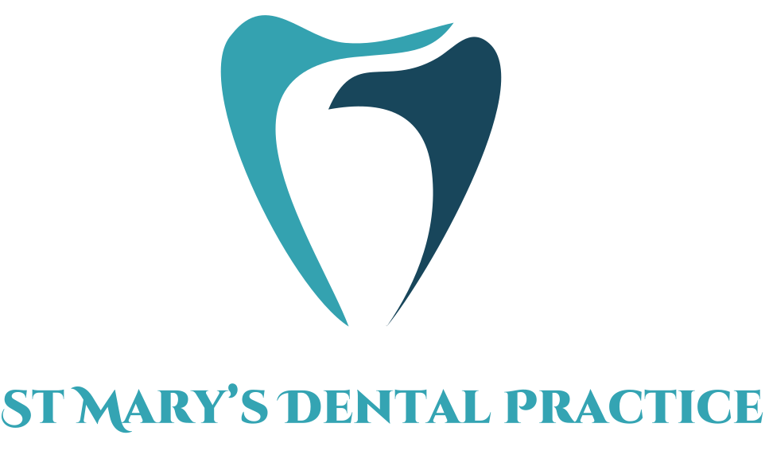

St Mary’s Dental Practice

Contact Number: 01353 662159
Email: Reception.stmarysdentalpractice@gmail.com

Address:
26 St Mary’s Street, Ely, CB7 4ES
Looking after your children’s teeth

Information for Patients

Tooth Brushing

- Tooth Brushing should be supervised by parents/careers until the age of 8
- As soon as teeth erupt, please visit the dentist for first routine exam
- Brush twice daily with fluoridated toothpaste (remember to brush gumline and each tooth)
- Spit out do not rinse. Rinsing out with mouthwashes or water after brushing, washes away the fluoride, reducing the effectiveness of the toothpaste

Fluoridated Toothpaste:
- For Children between ages of 0-6 , use toothpaste with no less then 1,000ppm fluoride
- From ages 7+ plus use toothpaste with no less then 1350ppm of fluoride
- Ages 0-3 use smear of toothpaste, 3+ use pea sized amount

- Disclosing tablets can be used , to see which areas are being missed whilst brushing
- Ages 8 and above a fluoridated mouthwash can be used, but only at different times to brushing
- Interdental cleaning such as using floss should be introduced from the age of 11.

Routine Dental Appointments
- Regular dental appointments are important to maintain good dental health, diagnose dental problems sooner and prevent complications
- Please attend regularly per recommended recall interval suggested by the dentist
- If any concerns arise in between appointments please call the practice

Eating and drinking advice
- Amount and frequency of sugary food and drinks should be reduced
- It is best to keep sugars and sweet treats to mealtimes
- Aim to replace sugary drinks with water, low-fat milk or sugar free drinks
- From 6 months of age infants should be introduced to a free flow cup and from age of 1, feeding from a bottle should be discouraged
- Sugar free medications should be recommended (Please seek support from doctors)
- `Follow Eat Well Plate for balanced diet
- Avoid any sugary foods and drinks at bedtime

