

St Mary’s Dental Practice

Contact Number: 01353 662159
Email: Reception.stmarysdentalpractice@gmail.com

Address:
26 St Mary’s Street, Ely, CB7 4ES
Root Canal Treatment

Information for Patients

As with any medical procedure there are some risks and benefits associated with each one:

Benefits
- You get to retain the tooth for longer, maintaining function and aesthetics
- Helps remove source of pain and infection

Risks
- Treatment may not be successful (10-20% of the cases) and symptoms may still continue, requiring further treatment (specialist involvement or extraction), this can be due to missed canals, extent of the infection, residual bacteria in canal etc.
- Fracture of tooth, meaning it may become unrestorable
- Fracture of thin dental metal files used to shape the canals
- Disinfectant leakage into surrounding tissues, that can cause pain or ulcerations (many precautions are taken to minimise this risk)
- Difficulty locating or negotiating canals
- Blockages of canals
- Accidental Perforations of the root

Why root canal treatment is not always successful?
- Amount of remaining tooth structure
- Lack of well-sealed restoration (lack of cuspal coverage if required)
- Oral hygiene and care post treatment
- Presence of extensive fracture
- Curved, narrow, calcified root canals
- Remaining, non-healing infection

Is Root canal procedure painful?
Pain during procedure is unusual: the dentist will place local anaesthetic to help numb up the tooth (unless the nerve is very inflamed and hard to numb up). But some post-operative discomfort can occur and over the counter pain-relief is sometimes recommended.
Root Canal treatment is an alternative treatment options to an extraction when the pulp (nerve and blood supply) inside the tooth has become inflamed, infected or died. This infection or inflammation is often caused by decay, deep cavities, repeated dental procedures on one tooth, cracks, and trauma.

If left untreated the infected pulp can cause severe pain, swelling, infection, spreading infection.

What is a root canal treatment?

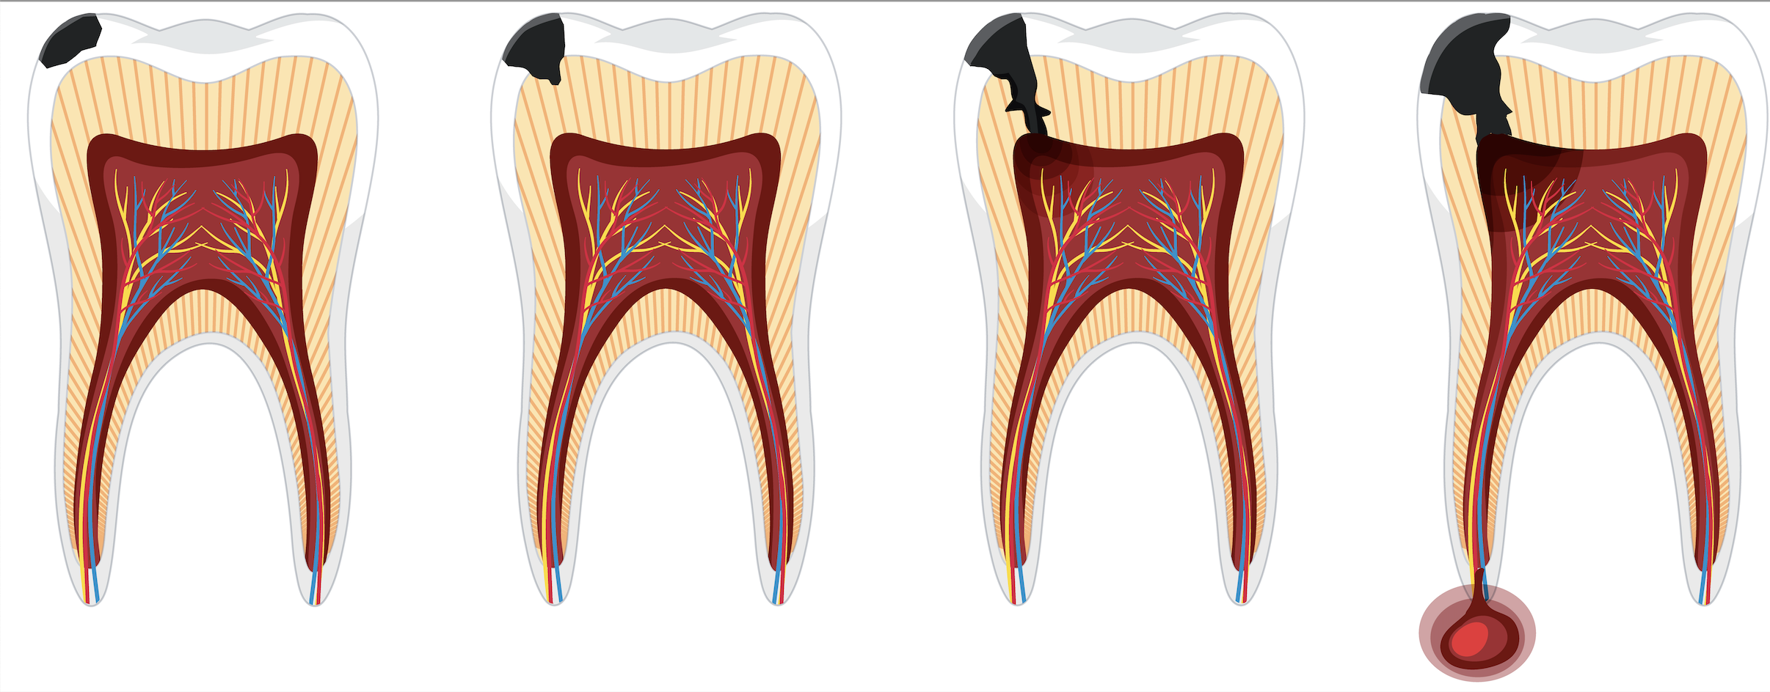

What are signs that the tooth requires root canal treatment?
- Prolonged sensitivity to hot and cold
- Tenderness to touch and chewing
- Discolouration of the tooth
- Swelling associated with a tooth
- Persistent pain, that is spontaneous , keeps you up at night

How does root canal save the tooth?
- The infected pulp is removed by the dentist, carefully cleans and shapes the canals and fills them up with a root filling material. You may need further treatment such as a dental cap on the tooth following treatment to prevent fracture

